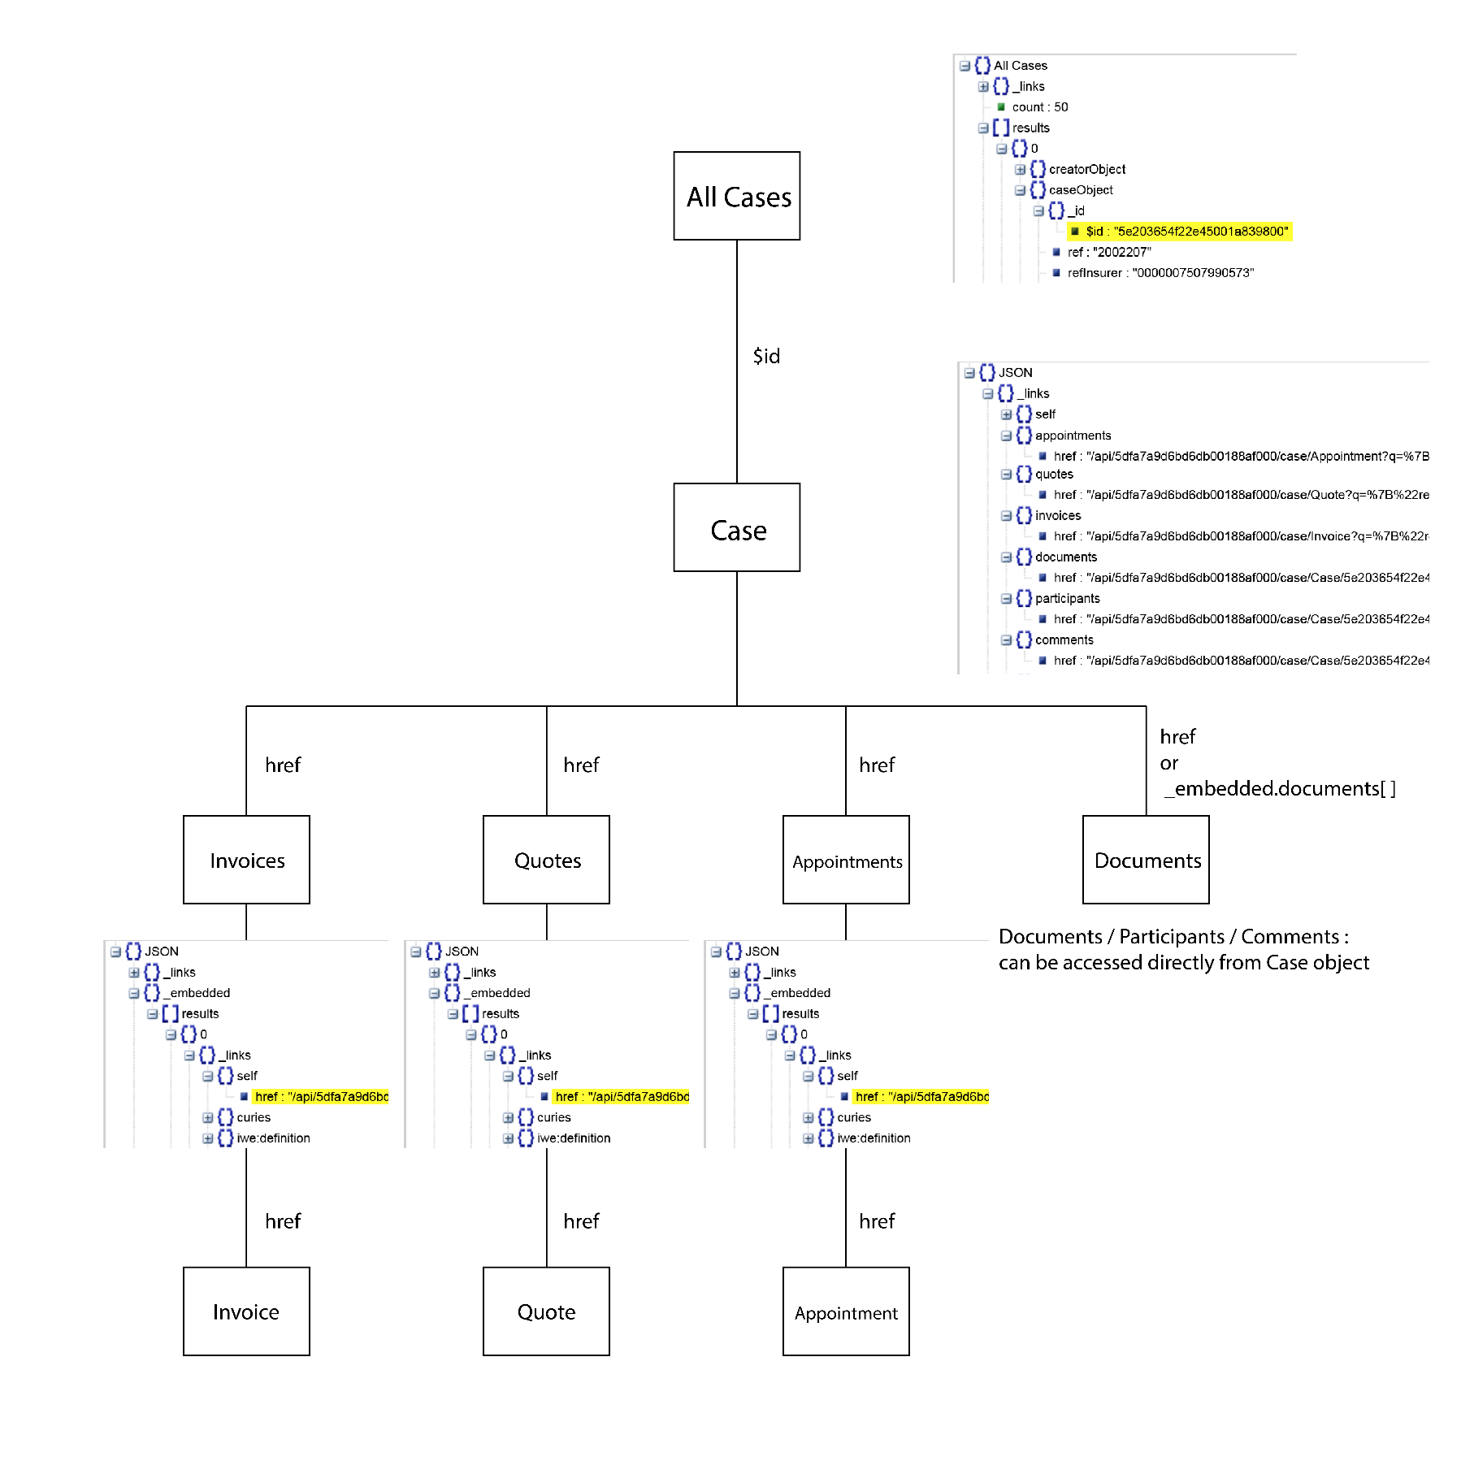

All cases:

fetch("https://uplink.i-we.io/api/query-executor/5dfa7a9d6bd6db00188af000/query/5dfb266c41a7f600185246d8/results?$sort=%7B%22Case.ref%22:1%7D&assignFilters=%7B%7D&filters=%7B%7D&page=1&perPage=50", {

    "credentials": "include",

    "headers": {

        "User-Agent": "Mozilla/5.0 (Windows NT 6.1; Win64; x64; rv:94.0) Gecko/20100101 Firefox/94.0",

        "Accept": "application/json, text/plain, */*",

        "Accept-Language": "fr",

        "x-window-id": "35f5ce23-91d2-4cd2-97b7-4032934c4fb1",

        "Authorization": jwt

        "Vary": "Accept-Language",

        "Sec-Fetch-Dest": "empty",

        "Sec-Fetch-Mode": "cors",

        "Sec-Fetch-Site": "same-origin"

    },

    "referrer": "https://uplink.i-we.io/",

    "method": "GET",

    "mode": "cors"

});

// Response => AllCasesResponse.json

Get first case Id from response:

*let* idDossier = allCasesResponseExample.results[0].caseObject._id.$id;

Particular case:

Link format: "/api/5dfa7a9d6bd6db00188af000/case/Case/{caseObject._id}"

fetch("https://uplink.i-we.io/api/5dfa7a9d6bd6db00188af000/case/Case/5e203654f22e45001a839800?view=full", {

    "credentials": "include",

    "headers": {

        "User-Agent": "Mozilla/5.0 (Windows NT 6.1; Win64; x64; rv:94.0) Gecko/20100101 Firefox/94.0",

        "Accept": "application/json, text/plain, */*",

        "Accept-Language": "fr",

        "x-window-id": "35f5ce23-91d2-4cd2-97b7-4032934c4fb1",

        "Authorization": jwt

        "Vary": "Accept-Language",

        "Sec-Fetch-Dest": "empty",

        "Sec-Fetch-Mode": "cors",

        "Sec-Fetch-Site": "same-origin"

    },

    "referrer": "https://uplink.i-we.io/",

    "method": "GET",

    "mode": "cors"

});

// Response => SingleCaseResponse.json

*let* quotesHref = singleCaseResponse._links.quotes.href;

*let* invoicesHref = singleCaseResponse._links.invoices.href;

Get quotes:

fetch("https://uplink.i-we.io/api/5dfa7a9d6bd6db00188af000/case/Quote?q=%7B%22relatedCase._id%22%3A%7B%22%24id%22%3A%225e203654f22e45001a839800%22%7D%7D&perPage=all&view=full", {

    "credentials": "include",

    "headers": {

        "User-Agent": "Mozilla/5.0 (Windows NT 6.1; Win64; x64; rv:94.0) Gecko/20100101 Firefox/94.0",

        "Accept": "application/json, text/plain, */*",

        "Accept-Language": "fr",

        "x-window-id": "2a1b3cae-8151-4248-9d13-dd56ba4ac185",

        "Authorization": jwt

        "Vary": "Accept-Language",

        "Sec-Fetch-Dest": "empty",

        "Sec-Fetch-Mode": "cors",

        "Sec-Fetch-Site": "same-origin",

        "If-None-Match": "W/\"10fac-0bld+30Jiy5GkqiQ9U0xRQCARlg\""

    },

    "referrer": "https://uplink.i-we.io/",

    "method": "GET",

    "mode": "cors"

});

// Response => AllQuotesResponse.json

*let* quoteHref = AllQuotesResponse._embedded.results[0]._links.self.href;

Get Invoices:

// Invoices (Factures):

fetch("https://uplink.i-we.io/api/5dfa7a9d6bd6db00188af000/case/Invoice?q=%7B%22relatedCase._id%22%3A%7B%22%24id%22%3A%225e203654f22e45001a839800%22%7D%7D&perPage=all&view=full", {

    "credentials": "include",

    "headers": {

        "User-Agent": "Mozilla/5.0 (Windows NT 6.1; Win64; x64; rv:94.0) Gecko/20100101 Firefox/94.0",

        "Accept": "application/json, text/plain, */*",

        "Accept-Language": "fr",

        "x-window-id": "2a1b3cae-8151-4248-9d13-dd56ba4ac185",

        "Authorization": jwt

        "Vary": "Accept-Language",

        "Sec-Fetch-Dest": "empty",

        "Sec-Fetch-Mode": "cors",

        "Sec-Fetch-Site": "same-origin",

        "If-None-Match": "W/\"6388-TsKKwPhQvCVRanf4uDgp9aVrOhU\""

    },

    "referrer": "https://uplink.i-we.io/",

    "method": "GET",

    "mode": "cors"

});

// Response => AllInvoicesResponse.json

*let* invoiceHref = AllInvoicesResponse._embedded.results[0]._links.self.href;

**Notes:**

1) “photos” key exists only in recognitions array (singleCaseResponse._embedded.recognitions[0].photos)

(Case reference: 2002174)

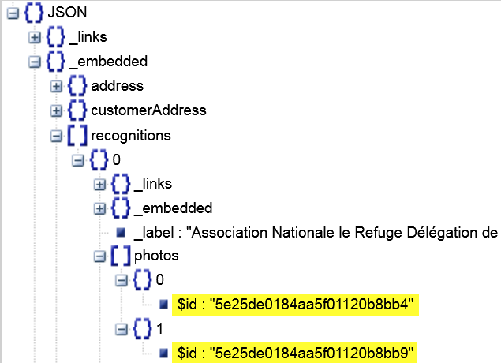

“photos” elements are found within case documents:

singleCaseResponse._embedded.recognitions[0]._links.photos.href:

"/api/5dfa7a9d6bd6db00188af000/case/Case/5e203654f22e45001a839800/documents/{id}"

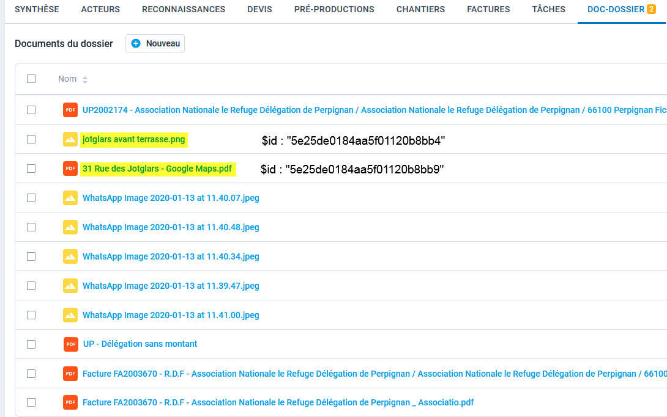

However, they have no direct reference in “Reconaissances”

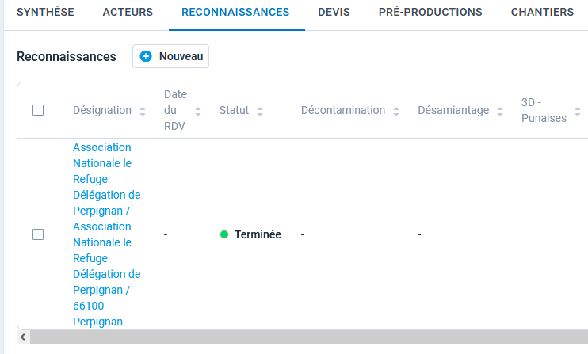

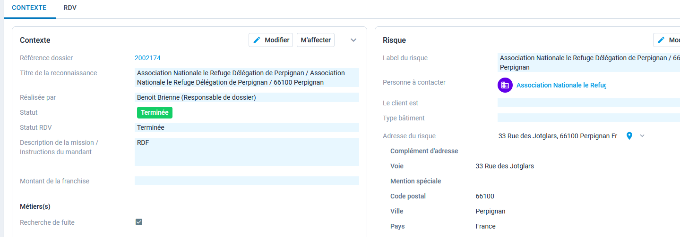

2) Quotes (Devis) have their own documents (Photos)

(Case reference: 2002008)

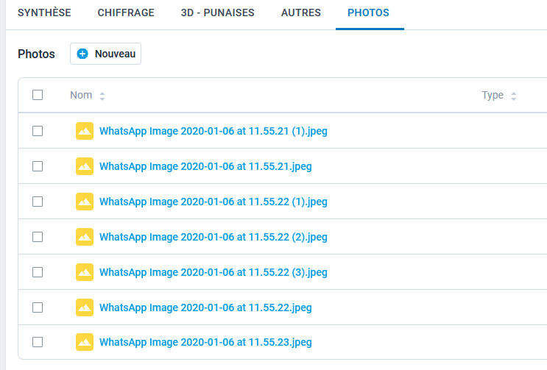

Generally they are not found in Case documents

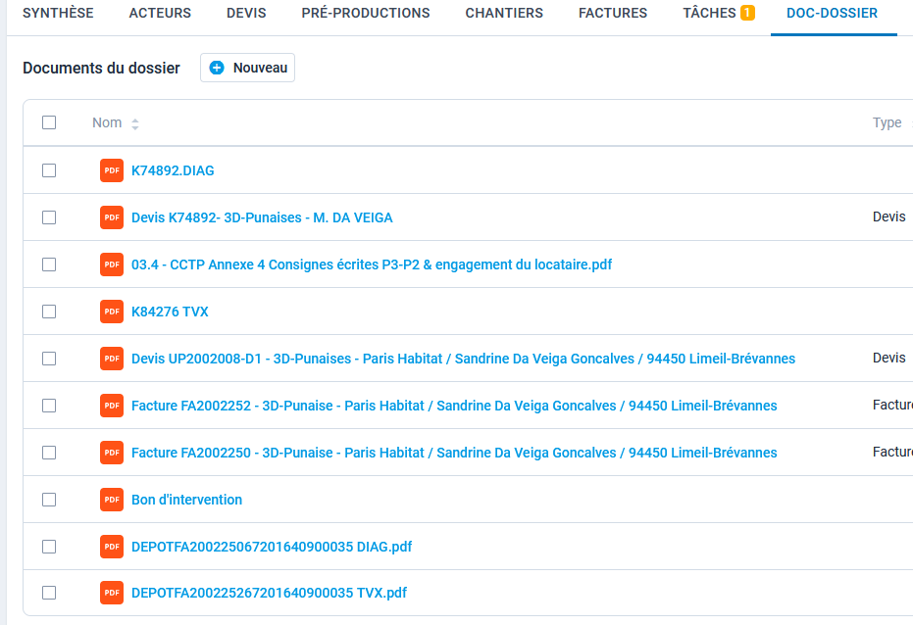

In some cases (Case references: 2002005, 2002140, 2002208, 2002261, 2002259) they are duplicated in case documents

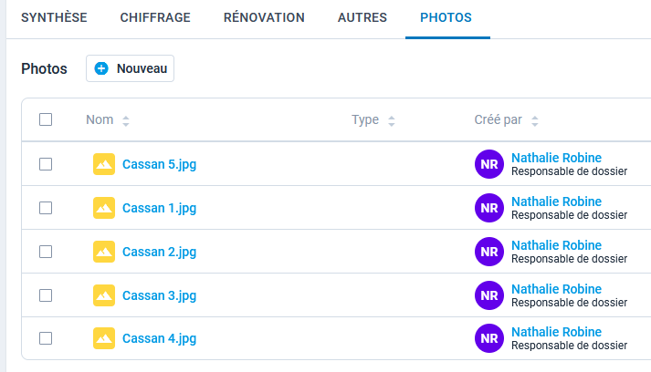

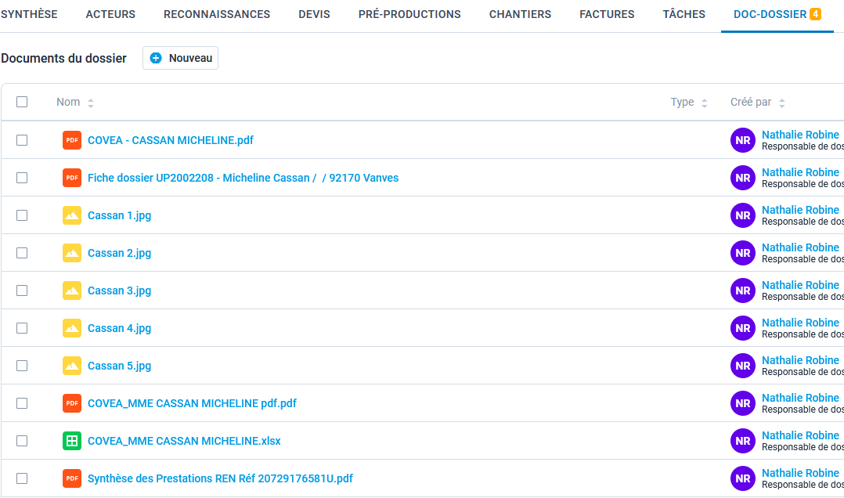

Quote documents are structured in the same way as Case documents:

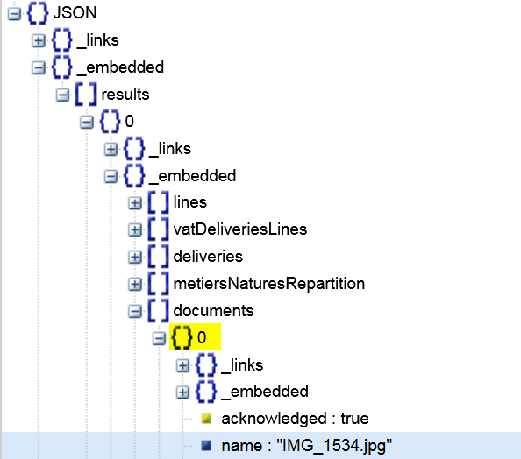

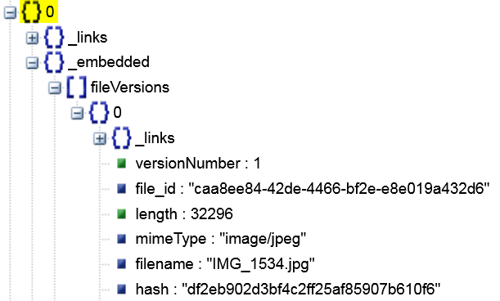

3) There are some quotes and invoices without a defined type: (Case reference: 2002024)

The filename doesn’t always start with “Devis” or “Facture” (2nd element on the list)

